React JS

1.What is React JS?

**ReactJS is a JavaScript librReact.js, commonly known as React, is an open-source JavaScript library developed and maintained by Facebook. It is primarily used for building user interfaces (UIs) for single-page applications where the UI needs to be dynamic and responsive. React allows developers to create reusable UI components, making it easier to manage and update complex user interfaces.**

2.What is NPM in React JS ?

**NPM stands for Node Package Manager. It is a package manager for JavaScript, and it is the default package manager for the Node.js runtime environment. NPM allows developers to easily manage and share reusable code (packages or modules) with others**

**3.What is Role of node JS in React JS?**

**Node.js and React.js are two separate technologies, but they can be used together to build modern web applications. Here's how Node.js and React.js are commonly used together:**

1. **Node.js as a Server:**
   * **Node.js is a runtime that allows you to run JavaScript on the server side. It's commonly used to build server-side applications.**
   * **When using React.js for building the frontend of a web application, Node.js can serve as the backend server.**
   * **Node.js can handle HTTP requests, perform server-side logic, and communicate with databases or other services.**

**4. What is CLI command in React JS?**

**In React.js, the command-line interface (CLI) is a set of tools that helps developers scaffold, build, and manage React applications more efficiently. The official React CLI is called "Create React App" (often abbreviated as CRA). It provides a pre-configured development environment and a set of scripts to handle common tasks**

**5. What is Components in React JS?**

**In React.js, components are the building blocks of a user interface. A React application is typically composed of multiple components that are organized in a tree-like structure. Each component represents a reusable piece of the user interface, and it can contain its own logic, state, and structure.**

**There are two main types of components in React:**

1. **Functional Components:**
   * **Also known as stateless components or presentational components.**
   * **Defined as JavaScript functions that take props (short for properties) as arguments and return React elements.**
   * **Typically used for simple, static, or stateless representations of the UI.**

.

**2.Class Components:**

* + **Also known as stateful components.**
  + **Defined using ES6 class syntax and must extend the React.Component class.**
  + **Can manage local state and have access to lifecycle methods.**

**6.** **What is Header and Content Components in React Js?**

**Header Component:**

* **A "Header" component in React typically represents the top section of a web page or application. It often contains elements such as a navigation bar, logo, and other UI elements that provide users with a quick overview or access to different sections of the application.**

**Content Component:**

**The "Content" component generally represents the main area of a web page where the primary content is displayed. This could include different sections, articles, or any other information relevant to the application.**

**7.** **How to install React Js on Windows, Linux Operating System? How to Install**

**NPM and How to check version of NPM?**

**To install React.js on Windows, Linux, or any other operating system, you need to follow a few steps. Additionally, installing React.js requires Node.js and npm (Node Package Manager). Here's a general guide for installing React.js on Windows and Linux:**

**Install Node.js and npm:**

**On Windows:**

1. **Visit the** [**official Node.js website**](https://nodejs.org/)**.**
2. **Download the latest LTS version for Windows.**
3. **Run the installer and follow the installation instructions.**
4. **npm is included with Node.js, so you don't need to install it separately**

**Install Create React App:**

**Once Node.js and npm are installed, you can use create-react-app to quickly set up a new React project.**

**Open a terminal or command prompt and run:**

**cd-my reactapp**

**npm start**

**Checking NPM version**

**npm-v**

**8.** **How to check version of React Js?**

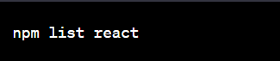

**This command will display the version of React.js that is currently installed in your project's node_modules directory.**

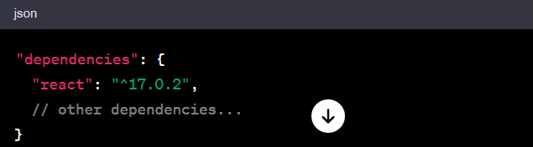

**Alternatively, you can open the package.json file in your project and look for the react dependency under the dependencies section. The version number will be specified there:**

**9.** **• How to change in components of React Js?**

**To change components in a React.js application, you typically modify the JSX code within your component files.**

**Edit the JSX Code:**

* **Open the file containing the component you want to change (e.g., a .jsx or .js file).**
* **Locate the JSX code that defines the structure and behavior of the component.**
* **Make the necessary changes to the JSX code. This can include modifying text, adding or removing elements, updating component state or props, etc**

**Save the Changes:**

**Save the changes you made to the component file.**

**Check the Result:**

**If you have your development server running (npm start), you can check the changes in your web browser by navigating to the local development server address (e.g., http://localhost:3000 by default).**

**10.** **How to Create a List View in React Js?**

